Table of Contents

Table of Contents 2
Introduction 2
Key 3
Off Page SEO 3
Ahrefs 5
Competitors 6
Backlinks 8
Google My Business 11
Detailed Competitor Analysis 13
Social Media 16
Summary and Conclusions 20
Areas for Improvement 20
Off Page 20
Competitors 21
Social Media 22
References and resources 22

Introduction
A Competitor Audit is the process of comparing your business and website to that of your competitors, with a specific focus on offpage factors such as backlinks and referring domains.

We choose 4 main competitors for comparison, based on your suggestions as well as our research into the SEO metrics of the particular companies’ websites. Sometimes the competitors we choose may differ from the ones you suggest - this may be because the competitors you suggest had a weak online presence, or were too much larger than you to provide a useful comparison.

The bulk of this audit is found in the Detailed Competitor Analysis. It is a separate document which contains hundreds of data points, but we summarise the main findings of the analysis in this document.

We additionally look at social media presence. We judge this based on a variety of factors from follower count to activity and engagement. The findings of this section pair well with the suggestions of the Content Strategy of the Content Audit.

This audit should be used to inform offpage SEO goals from backlink acquisition to social media to strategies to adjust your business to your competitors’ strengths and weaknesses.

Key

Green - Done well / trivial room for improvement
Orange - Done poorly / room for improvements
Red - Current state is detrimental to overall SEO / completely unimplemented
Blue - Our recommendation

Off Page SEO

lOFF PAGE SEOl
Search engine ranking factor survey data has shown that getting external links is the single most important objective for attaining high rankings. This stems from the idea that external links are one of the hardest metrics to manipulate and thus, one of the best ways for search engines to determine the popularity of a given web page. This idea was first used by the early search engine Alta Vista and later improved upon by Google.

Google first made its mark by introducing the Stanford community to PageRank (an algorithm developed by Google co-founder Larry Page). This algorithm counted hyperlinks as votes for popularity. The pages that had the most links pointing at them were considered the most popular. When they were deemed relevant for a particular query, the most popular and relevant pages would become the first pages listed in Google's results. Although this algorithm is much more complex today, it still likely includes the notion of external links as votes.

Basically the more quality backlinks you have the higher you rank.
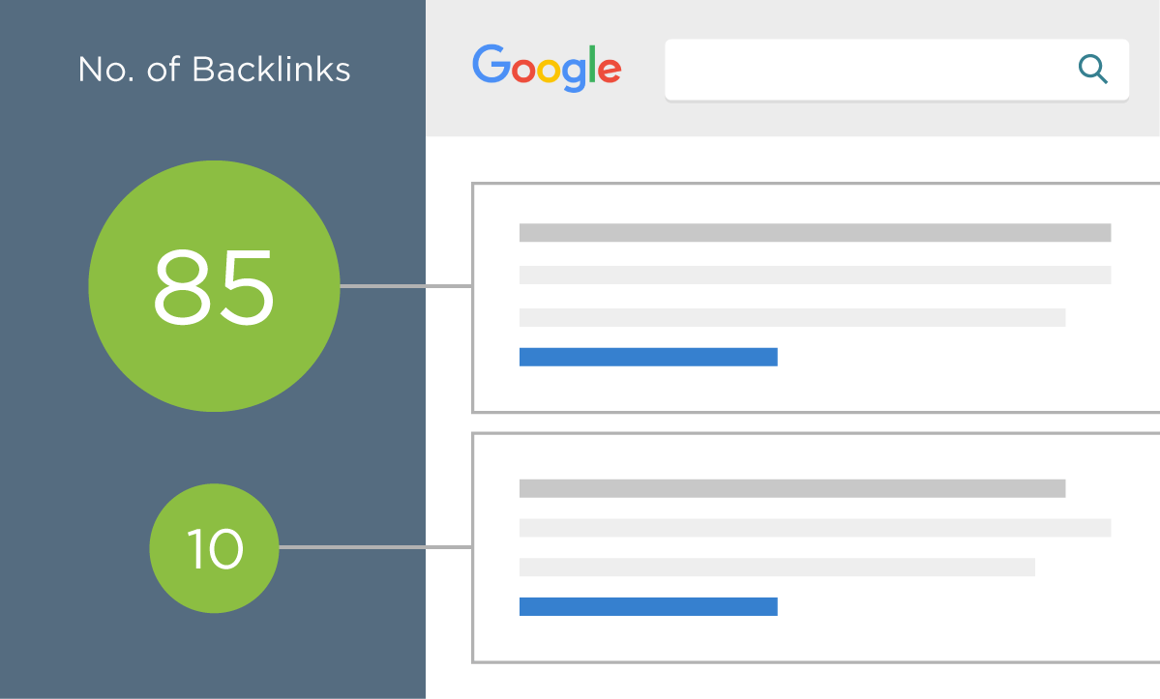
Today, the major search engines use many metrics to determine the value of external links. Some of these metrics include:
- The trustworthiness of the linking domain.
- The popularity of the linking page.
- The relevancy of the content between the source page and the target page.
- The anchor text used in the link.
- The number of links to the same page on the source page.
- The number of root domains that link to the target page.
- The amount of variations that are used as anchor text to links to the target page.
- The ownership relationship between the source and target domains.
In addition to these metrics, external links are important for two main reasons:

Popularity
Whereas traffic is a "messy" metric and difficult for search engines to measure accurately (according to Yahoo! search engineers), external links are both a more stable metric and an easier metric to measure. This is because traffic numbers are buried in private server logs while external links are publicly visible and easily stored. For this reason and others, external links are a great metric for determining the popularity of a given web page.

Relevancy
Links provide relevancy clues that are tremendously valuable for search engines. The anchor text used in links is usually written by humans (who can interpret web pages better than computers) and is usually highly reflective of the content of the page being linked to. Many times this will be a short phrase (e.g., "best aircraft article") or the URL of the target page (e.g., http://www.best-aircraft-articles.com).

The target and source page, as well as the domain cited in a link also provide valuable relevancy metrics for search engines. Links tend to point to related content. This helps search engines establish knowledge hubs on the Internet that they can then use to validate the importance of a given web document.

Ahrefs
We use a premium tool called Ahrefs to get insight into your backlink profile. Every website is given an Ahrefs Rank, UR and DR:

Ahrefs Rank (AR) shows the target website's position among all other websites in our database rated by the "strength" of their backlink profiles. The website with the strongest backlink profile is ranked #1.

URL Rating (UR) shows the strength of the target URL's backlink profile on a 100-point logarithmic scale Both internal and external links influence this metric.

UR has a clear positive correlation with Google rankings, meaning that high-UR pages tend to rank higher in the organic search results. When the whole domain is analyzed in Site Explorer, URL Rating will be shown for the homepage.

Domain Rating (DR) shows the strength of a website's backlink profile compared to the others in the Ahrefs database on a 100-point logarithmic scale. DR is calculated based on the number of websites linking to the domain’s URLs and their backlink profile strength.

Both UR and DR scale logarithmically with higher values being better.

DATA COLLECTION: www.pikelandpropertygroup.com/
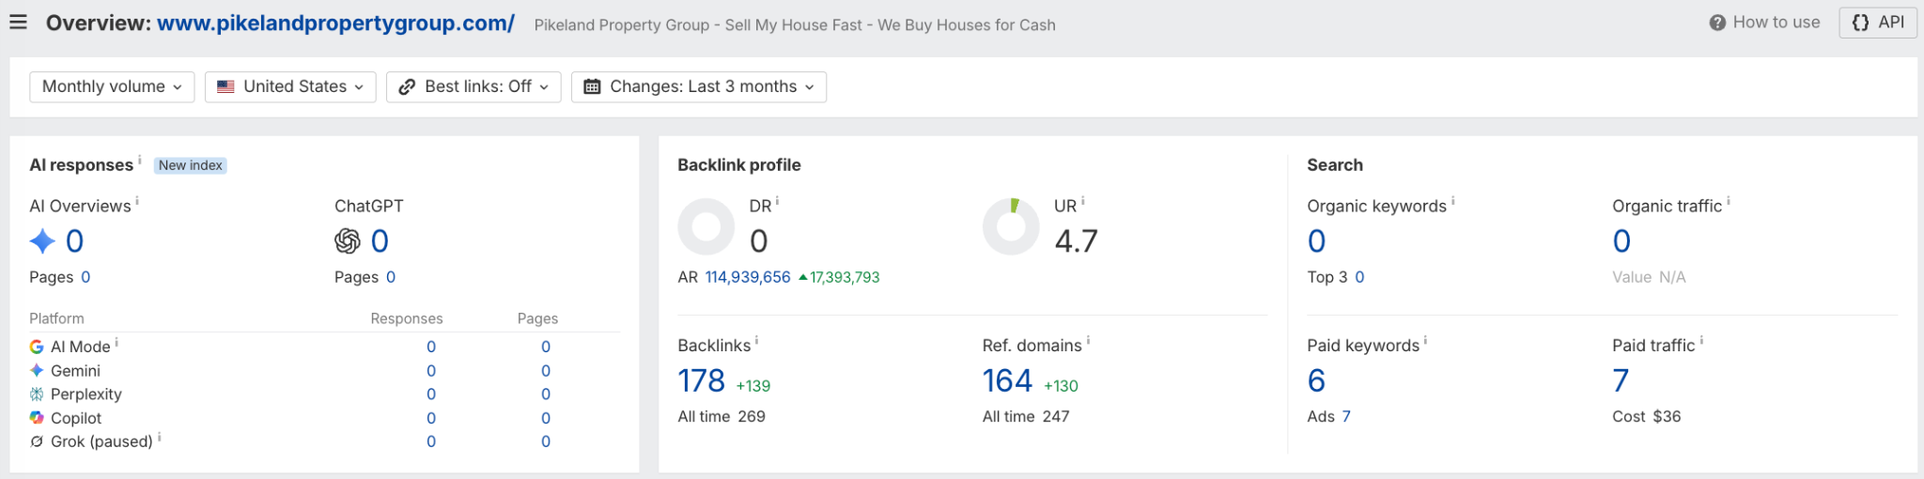

Competitors
From the wider data set reviewed in the Initial Competitor Analysis and Detailed Competitor Analysis sheets below, we selected four competitors for the focused report narrative. The wider review includes the businesses you nominated, as well as additional companies identified through SERP research, keyword relevance, organic visibility, backlink strength and business-model fit.

717 Home Buyers and Diamond Equity were selected from your competitor set because they are relevant cash-home-buyer businesses with meaningful SEO, content, local and backlink data.

SoldFast and Sell My House Fast were added by Woww because they rank for highly relevant non-branded ‘sell my house fast’, ‘we buy houses’ and cash-home-buyer searches, including terms and location patterns relevant to Pikeland’s target market.

This focused mix gives us two commercially relevant client-nominated competitors and two strong search competitors.

Larger national portals such as Zillow and Opendoor remain useful context, but are not used as core benchmarks; the remaining nominated competitors have insufficient non-branded visibility or comparable data to provide as useful a main comparison.

DATA COLLECTION: 717homebuyers.com
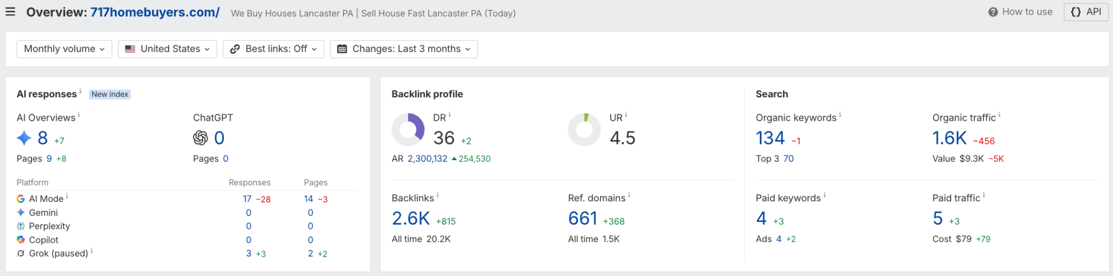

DATA COLLECTION: diamondequity.com

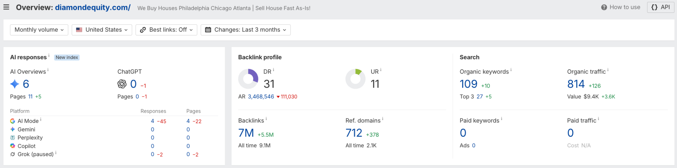

DATA COLLECTION: soldfast.com

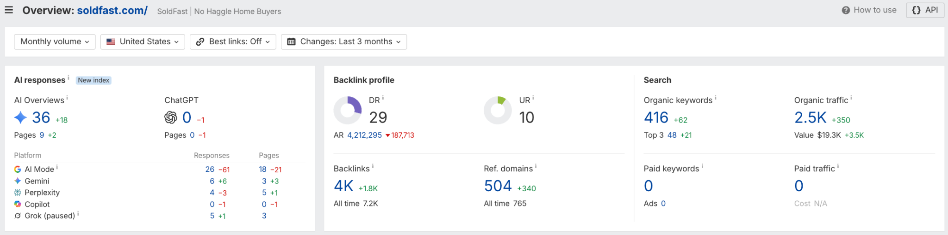

DATA COLLECTION: sellmyhousefast.com

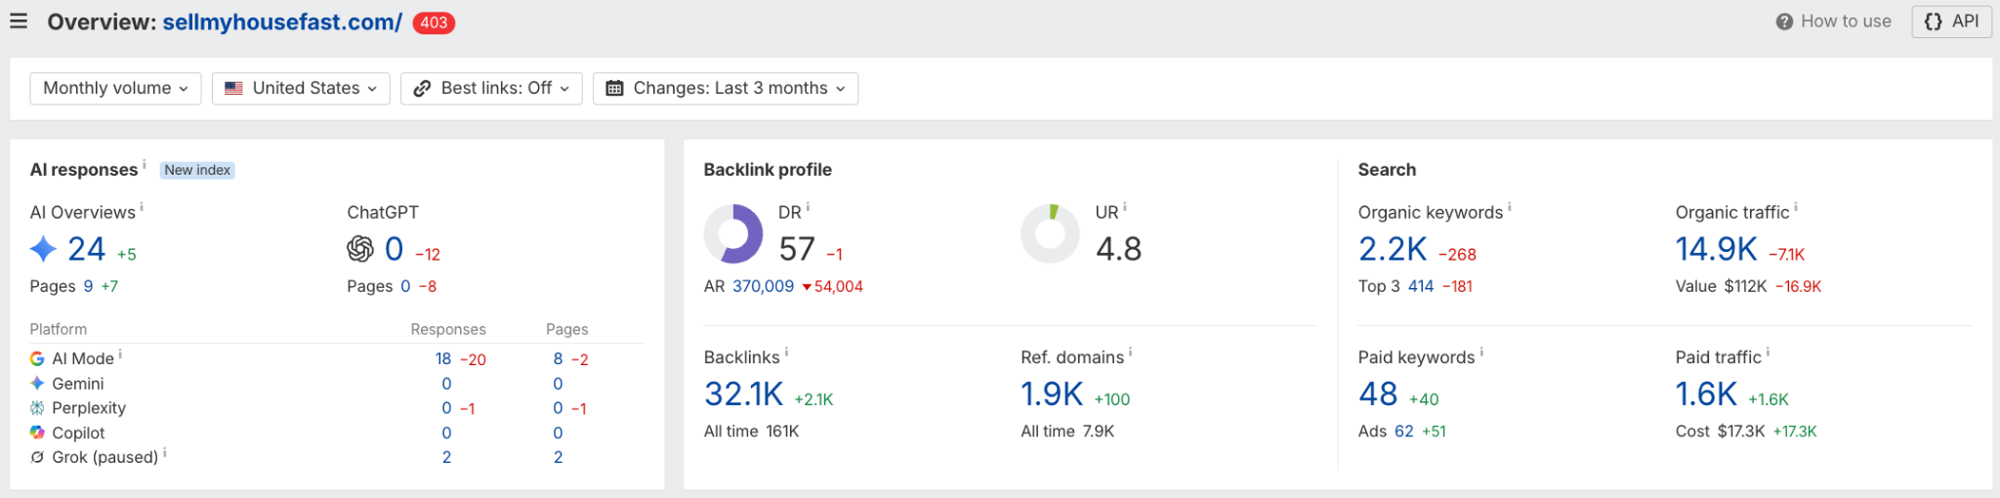

DATA COLLECTION: Referring domains over time

Key competitors for detailed comparison:
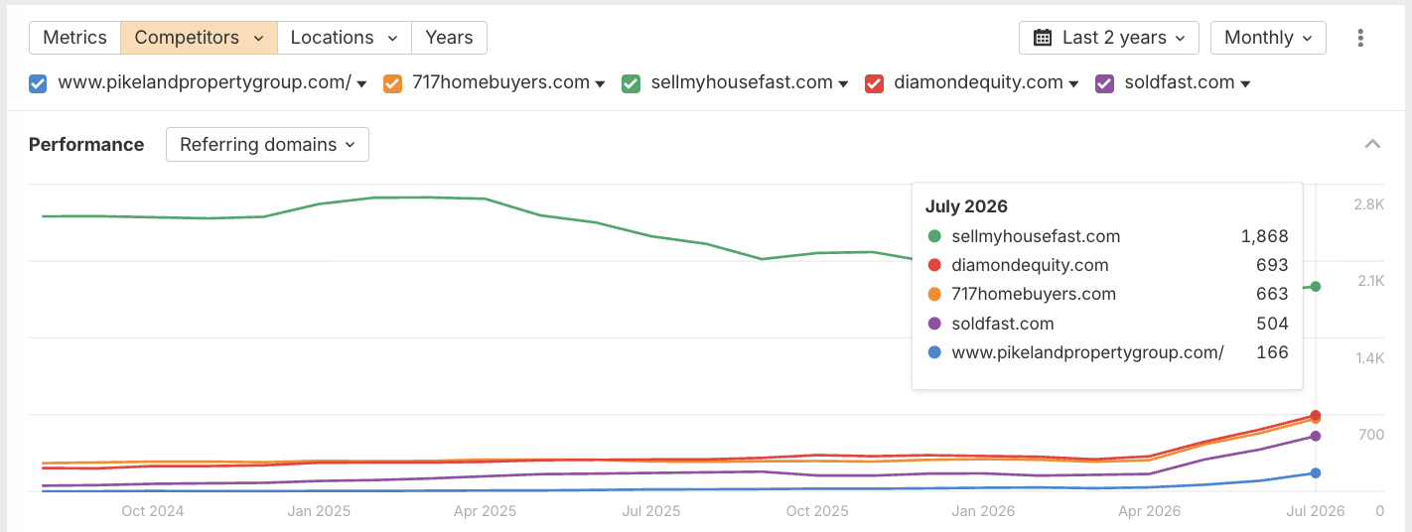
Expanded list of competitors:
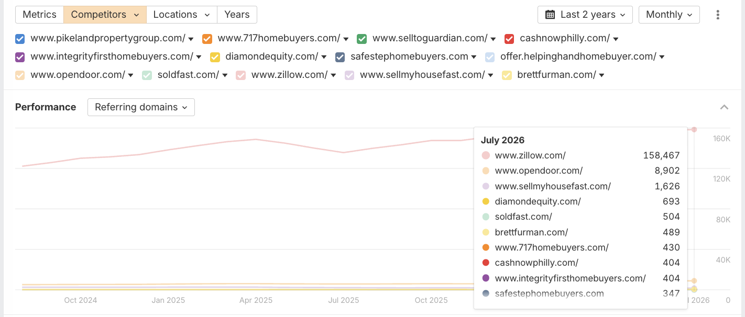

Expanded list of competitors without Zillow and Opendoor:
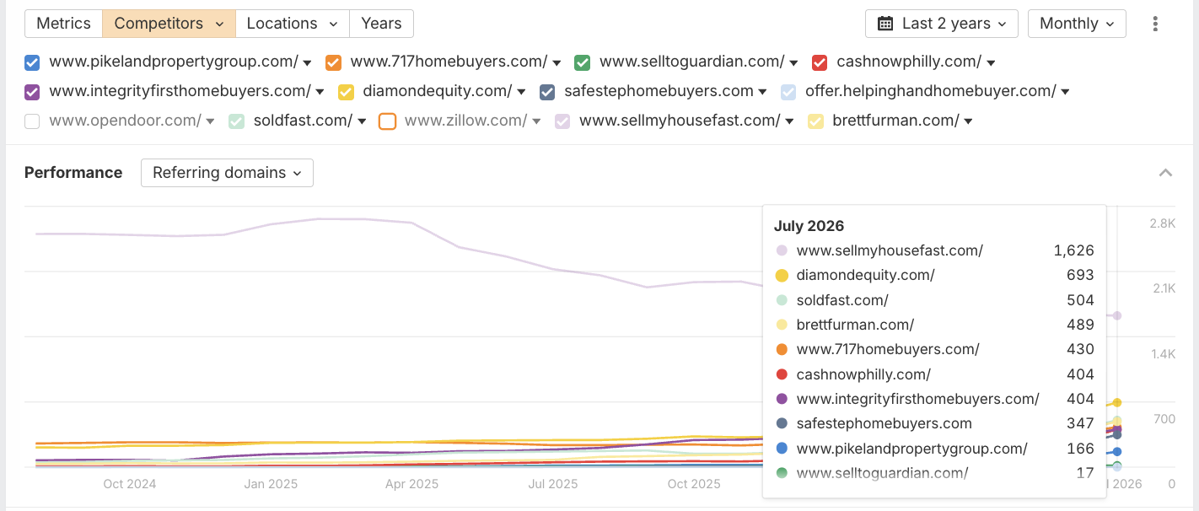

DATA COLLECTION

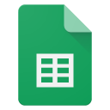 | Backlinks
 | Backlink anchors
 | Referring domains
 | Link intersect [your competitors have these backlinks, but you don’t]

FINDINGS

- Pikeland’s data shows 5,497 referring-domain rows, but the comparable Ahrefs summary shows a low-authority profile: DR 0, 179 backlinks and 164 referring domains.
- Only 21 backlinks are do-follow, coming from 14 domains; this is the most important actionable measure of link equity in the current profile.
- Pikeland has no reported organic traffic or top-10 keyword visibility in the comparison dataset.
- Some legitimate sources already link to Pikeland, including BBB, Datanyze, TheOrg and Klazify.
- 717 Home Buyers, Diamond Equity, SoldFast and Sell My House Fast all have materially stronger authority and organic visibility.
- 717 has 202 do-follow referring domains, SoldFast has 93, and Sell My House Fast has 1,371; the latter is a useful scale benchmark, not a like-for-like local target.
- The profile also includes many obvious link sellers, PBNs, and low-traffic domains, so raw referring-domain volume should not be treated as an authority.
- The backlink export includes seller/PBN examples such as buybacklinks.agency, ranklinkerpro.shop and Dark Side Links placements.
- Anchor data is a clear quality concern: alongside natural brand and URL anchors, it also contains promotional SEO, Telegram, and DR/DA/TF uplift text.
- Competitors are supported by stronger followed-link profiles and substantially more organic keyword coverage, so quality and relevance need to be prioritised over volume.
- The link-intersect identifies credible prospects for link building to acquire links Pikeland does not currently have, including HomeLight, Birdeye, DexKnows, List With Clever, Realtor.com, BiggerPockets, Carrot and ProvenExpert.

RECOMMENDATIONS
- Prioritise relevant, editorial and locally useful do-follow links over raw link volume.
- Do not buy links from link sellers, PBNs, automated networks, hacked sites or zero-traffic directories.
- Review new links and anchor text regularly; investigate unusual patterns if rankings or Search Console signals deteriorate.
- Build citations and local trust links from relevant Pennsylvania and Delaware business directories, chambers, real estate resources, and community organisations.
- Use legitimate link-intersect prospects as starting points, not guaranteed placements.
- Prioritise HomeLight, Birdeye, DexKnows, List With Clever, Realtor.com, BiggerPockets, Carrot and ProvenExpert after manual relevance checks.
- Explore local press, property-industry associations, community sponsorships, partner pages and vendor testimonials for editorial placements.
- Build links to the homepage, Get Your Offer page, and the most important location/service landing pages - not only the root URL.
- Create linkable seller resources: probate, inherited-property, foreclosure, as-is sale and cash-offer explainers for target locations.
- Use a natural anchor mix: Pikeland Property Group, pikelandpropertygroup.com, URL anchors, service phrases and location-plus-service phrases.
- Avoid repeated exact-match commercial anchors such as ‘we buy houses Philadelphia’ at scale.
- Track acquired domains, page targets, anchor text, referral traffic and resulting ranking movement.
- Refer to the keyword intersect section of the content audit to see the relevant keywords your competitors rank for but you don’t.

Google My Business
An important first step in any local SEO strategy is to claim and verify your local business’s Google My Business (GMB) listing. Getting on Google My Business can increase your chances of showing up in Google’s Local Pack, Local Finder, Google Maps, and organic rankings in general.

Qualifying local businesses can claim a free listing on Google and include information about their company, such as their address, phone number, business hours, and types of payment accepted.

Additionally, over the past several months, Google has added some great features to Google My Business that companies should take advantage of to enhance their listings and help grab viewers’ attention - and can increase their rankings in local search results.

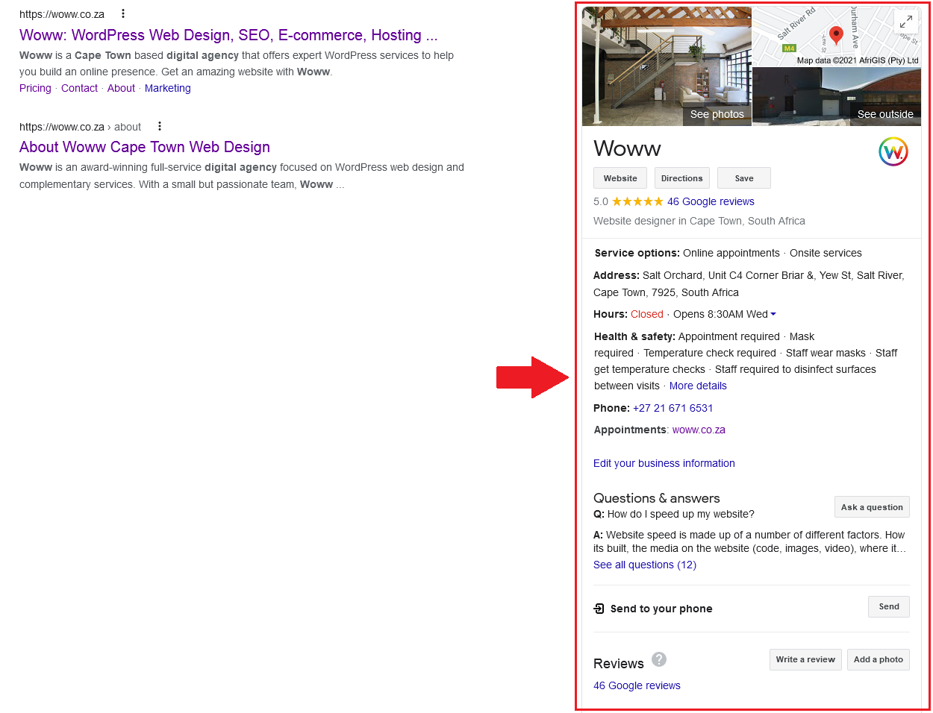
This is an example of the Woww Google My Business account. As you can see, it has useful information (such as contact info and hours) and a 5-star rating with a fair number of reviews.
FINDINGS

- Pikeland has a visible Google Business Profile.
- It has 115 reviews and a 5.0-star rating - the strongest review profile in the selected comparison set.
- Website, contact details and business information should be checked routinely for consistency.
- GBP should support the same location and cash-home-buyer pages that are being prioritised for organic search.
- Pikeland’s review count is ahead of 717 Home Buyers (82) and SoldFast (101); Diamond Equity has profiles with 62 and 110 reviews.
- Sell My House Fast is recorded with 20 reviews and a 4.4 rating, so Pikeland’s current rating and review count are a strong asset.
- The main gap is profile imagery: 717 has approximately 20–30 images, and SoldFast has approximately 20, versus Pikeland’s one.
- More current, authentic photos can improve conversion confidence and profile completeness without changing Pikeland’s strong review position.
- There is a second listing with no reviews with the same address. Appears to be a duplicate listing. Ensure only 1 exists - this one should remain.
- The profile has only one listed image, which is a significant completeness and trust opportunity.
- Pikeland is well positioned in terms of review quality, but the listing is visually underdeveloped.
- The immediate local opportunity is to protect review momentum while improving photos, services, posts, Q&A and links to relevant landing pages.
- The posts section is not being used to publish Pikeland Property content visible to users.
  - This is done by certain competitors.

RECOMMENDATIONS
- Ensure only 1 GBP listing exists - this one should remain.
  - There is a second listing with no reviews with the same address.
- Keep review generation active after completed purchases, using a simple compliant request process.
  - Explore other relevant business directories where you can increase reviews, and subsequently positive review signals for crawlers.
- Respond to every review promptly and professionally, especially where a customer names a location or service.
- Add a meaningful set of authentic photos: team, completed property context, local areas, branded materials, and office/service imagery.
- Complete all relevant services, business description, service areas, attributes and appointment/contact options.
- Publish regular Google Posts around cash offers, inherited homes, foreclosure help, as-is sales and target-location updates.
- Seed and maintain useful GBP Q&A that addresses seller concerns and qualification questions.
- Check business name, address, phone, website URL and hours for consistency across citations and the site.
- Link the GBP to the most relevant website page, rather than a generic or mismatched destination.
- Strengthen the relevant location pages with local proof, FAQs, service detail and prominent offer CTAs.
- Monitor profile calls, website clicks, direction requests, reviews and photo views monthly.


Detailed Competitor Analysis
lDETAILEDl lCOMPETITORl lANALYSISl
We put together a spreadsheet with 4 competitors, measuring company context, content activity, SEO, backlink quality, local signals and social media. This gives insight beyond raw traffic or link counts.
This is to give some insight in comparing companies on more than just SEO data.

 | Initial Competitor Analysis
 | Detailed Competitor Analysis

ANALYSIS SUMMARY: https://www.pikelandpropertygroup.com/
- Pikeland Property Group’s domain is four years old, registered 25 March 2022.
- The blog sitemap contains 20 posts, but publishing appears inactive since 2024.
- Content is generally thin: blogs are typically 600–650 words and landing pages need more depth, media and supporting sections.
- Core metadata needs work: some titles are short or incomplete, blog titles/descriptions are often too long, and key pages lack descriptions.
- Internal linking is limited, and some location pages are orphaned, reducing their ability to rank.
- Image use and alt text are limited; location and service pages need more original, contextual visuals.
- Pikeland has a GBP with 115 reviews and a 5.0 rating, but only one listed image.
- SEO metrics: DR 0, UR 4.7, 164 referring domains, 179 backlinks, 21 do-follow links from 14 domains, and no reported organic traffic or top-10 keywords.
- The priority is to turn the existing local offer and strong review profile into crawlable, internally linked location and service pages supported by higher-quality links.

ANALYSIS SUMMARY: https://www.717homebuyers.com/
- 717 Home Buyers is a client-nominated, like-for-like Pennsylvania competitor with a seven-year-old domain.
- It maintains an active blog: 17 posts in the past year and approximately 120 articles overall.
- Its content is generally stronger than Pikeland’s, with author bios, useful internal links and structured data.
- Location coverage is a key advantage: many dedicated Pennsylvania pages support local intent and rankings.
- It ranks strongly for relevant terms including cash-for-houses and sell-my-house searches across Lancaster, York, Harrisburg and other PA locations.
- GBP: 82 reviews, 4.8 rating and approximately 20–30 images.
- SEO metrics: DR 36, 1,566 estimated organic visits, 661 referring domains, 2,635 backlinks, 1,500 do-follow links from 202 domains, and 126 top-10 keywords.
- 717 is the clearest local benchmark for page structure, local landing-page coverage, internal linking and content consistency.

ANALYSIS SUMMARY: https://diamondequity.com/
- Diamond Equity is a client-nominated competitor with a long-established 23-year-old domain.
- It publishes actively, with roughly 50–60 recent posts and approximately 117 articles overall.
- Content has useful internal linking and good location-page coverage, including a Philadelphia cash-home-buyer page.
- Some blog content is short and metadata can be overlong, so it is not a perfect on-page model.
- Diamond has two observed GBP profiles with 62 and 110 reviews, ratings of 4.7 and 4.1, and limited-to-moderate image coverage.
- SEO metrics: DR 31, 804 estimated organic visits, 713 referring domains, and 94 top-10 keywords.
- Its 7m+ backlink total is an obvious outlier; use its followed referring-domain count (210) and content/local-page structure as the more useful comparison.
- Diamond demonstrates the advantage of established authority and broad location coverage, but Pikeland should not imitate its raw backlink volume.

ANALYSIS SUMMARY: https://soldfast.com/
- SoldFast is a strong SEO/SERP competitor with a 29-year-old domain and a multi-state cash-home-buyer model.
- It has an active content programme: about 20 posts in the past year and 27 articles overall.
- Content is accessible, usually supported by sound headings and structured data, although some pages could be deeper.
- It has a relevant Pennsylvania/Harrisburg page and ranks for cash-for-houses and sell-my-house-fast searches, including Harrisburg terms.
- GBP: 101 reviews, 5.0 rating and approximately 20 images.
- SEO metrics: DR 29, 2,050 estimated organic visits, 503 referring domains, 4,019 backlinks, 591 do-follow links from 93 domains and 367 top-10 keywords.
- SoldFast is especially useful as a benchmark for location templating, organic keyword coverage and regular content publishing.
- Its scale is broader than Pikeland’s, so the transferable lesson is repeatable local page quality - not matching every market.

ANALYSIS SUMMARY: https://www.sellmyhousefast.com/
- Sell My House Fast is the strongest search-visibility benchmark in the selected group, with a 26-year-old domain.
- It has extensive nationwide location coverage and content depth, with 17 articles and an estimated 5–10 posts per month.
- Its pages are generally substantial, supported by structured data and author information, although some heading, sitemap and metadata issues remain.
- It ranks for many highly relevant Pikeland-market terms, including Lancaster, Reading, Philadelphia, Wilmington, Coatesville and Pittsburgh searches.
- GBP visibility is less clear, but the analysis records 20 reviews, a 4.4 rating and approximately 8–10 images.
- SEO metrics: DR 57, 18,363 estimated organic visits, 1,621 referring domains, 29,296 backlinks, 28,276 do-follow links from 1,371 domains and 1,885 top-10 keywords.
- Use Sell My House Fast as a keyword and location-page benchmark, not as a direct scale target.
- Pikeland should prioritise the location/intent clusters it can serve credibly, then build quality and authority incrementally.

RECOMMENDATIONS
- Prioritise high-intent service and location pages before expanding low-value blog output.
- Create or strengthen pages for cash home buyers, sell house fast, we buy houses and as-is sale intent in Pikeland’s priority markets.
- Start with Philadelphia, Wilmington, Lancaster, Reading, York, Coatesville, Pottstown, Phoenixville, Upper Darby and Pittsburgh based on the target-market plan.
- Give each page a unique H1, location-specific evidence, clear offer CTA, FAQs and internal links to related services.
- Improve core metadata: fix short, missing, generic and overlong titles/descriptions; avoid visible template remnants on location pages.
- Use clear heading hierarchy and add supporting sections that answer seller concerns rather than generic filler.
- Resume a sustainable blog/resource programme aligned to seller questions: probate, inherited homes, foreclosure, repairs, timelines and cash-offer process.
- Use 717 as the local structural benchmark for PA location coverage and internal linking.
- Use SoldFast and Sell My House Fast as keyword coverage and scalable landing page benchmarks.
- Use Diamond Equity as an authority/local-page benchmark, while ignoring raw backlink-total outliers.
- Strengthen the homepage as a gateway to offers, services and priority locations - not the only page expected to rank.
- Improve internal links from the homepage, offer page, blogs and location pages using descriptive anchor text.
- Add original images and meaningful alt text to commercial and location pages.
- Add appropriate structured data to key pages, following the Technical Audit’s guidance.
- Improve conversion paths: show trust signals, reviews, seller FAQs and a consistent Get Your Offer CTA.
- Build higher-quality local and property-industry links to support the new pages.
- Keep GBP and website location data aligned, with each relevant profile linked to the best matching page.
- Fix or replace broken social links in the footer so website visitors can reach live profiles.
- Use social posts to amplify new location pages, seller resources, reviews and local trust signals.
- Track organic traffic, top-10 keywords, local rankings, referring-domain quality, review growth and conversions monthly.
- Use the completed Content and Technical Audits to sequence work and avoid duplicated effort.


Social Media
lSOCIAL MEDIA &l lSOCIAL SIGNALSl
Social signals are human interaction metrics on social platforms like Facebook, Twitter, LinkedIn, Reddit, Medium, etc. Some examples of social signals are: likes, dislikes, shares, votes, pins, views, etc. which commonly help to showcase popularity and affinity for a specific piece of content.

Studies have concluded that Social signals are included as a ranking factor, we outline and identify your social presence and the impact it’s having on your SEO.

SOCIAL SUMMARY:
Pikeland Property Group: https://www.pikelandpropertygroup.com/
- Social icons are present, but the Facebook and Instagram links appear broken.
- Facebook: 92 followers; last post approximately one year ago.
- Instagram: 184 followers; one observed post, last active 19 October 2025.
- LinkedIn: 76 followers; no observed posting activity.
- YouTube and X/Twitter were not found.
- Social activity is currently too limited to provide a meaningful advantage in trust, content distribution, or local visibility.

SOCIAL SUMMARY:
717 Home Buyers: https://www.717homebuyers.com/
- Facebook: 868 followers; roughly 5–10 posts per month with video content.
- Instagram: 319 followers; approximately 5–11 posts per month.
- YouTube: 20 subscribers, 54 videos and 146,121 total views.
- LinkedIn: 56 followers; last activity was approximately four years ago.
- 717’s advantage is consistent Facebook/Instagram activity and a usable video library, despite modest audience size.

SOCIAL SUMMARY:
Diamond Equity: https://diamondequity.com/
- Facebook: approximately 1.3k followers; 1–3 posts per month with video content.
- YouTube: 24 subscribers, 318 videos and 251,131 total views.
- Instagram: 14 followers and inactive.
- LinkedIn: 631 followers; limited recent posting.
- Diamond uses video at scale, although its posting consistency and platform mix are uneven.

SOCIAL SUMMARY:
SoldFast: https://soldfast.com/
- Facebook: 317 followers; approximately 3–10 posts per month and 13 reels, with several exceeding 10k views.
- Instagram: 313 followers; 1–5 posts per month when active, with modest engagement.
- YouTube: 23 subscribers, 34 videos and 9,938 total views.
- LinkedIn: 39 followers; no observed posts.
- SoldFast shows that short-form video can create reach even without a large follower base.

SOCIAL SUMMARY:
Sell My House Fast: https://www.sellmyhousefast.com/
- Facebook: 516 followers; last observed post in 2024.
- Instagram: 234 followers; last observed activity in 2022.
- YouTube: 10 videos and 642 views.
- LinkedIn: 48 followers; no observed posts.
- X/Twitter: 16 followers; last observed activity in 2022.
- Sell My House Fast’s social profiles are weak/inactive, showing that organic visibility does not depend on social scale alone.

RECOMMENDATIONS
- Fix the Facebook and Instagram links in the website footer; link only to live, maintained profiles.
- Choose Facebook and Instagram as the two immediate priority channels, with LinkedIn as a light-touch business/trust channel.
- Restart a realistic cadence: two to four useful posts per month per priority channel before increasing volume.
- Use short-form video to explain the cash-offer process, as-is sales, inherited homes, foreclosure options and local seller questions.
- Repurpose each new location page, FAQ, or seller resource into social posts that drive users back to the site.
- Show trust: reviews, team, local community, clear process steps, anonymised seller outcomes where permitted and behind-the-scenes content.
- Use location-specific posts for Philadelphia, Wilmington, Lancaster, Reading, York and other priority areas.
- Use Facebook/Instagram Stories and Reels where practical; SoldFast shows that Reels can gain reach despite a modest following.
- Use LinkedIn for company updates, partnerships, recruitment, local credibility and review/press milestones.
- Consider YouTube only once there is a repeatable supply of useful video; do not create a channel simply to match competitors.
- Track follower growth, reach, engagement, video views, website clicks and assisted enquiries, then repeat formats that perform.


Summary and Conclusion
lSUMMARY &l lCONCLUSIONl

Summary and Conclusion
Pikeland Property Group is a younger local cash-home-buyer business with a strong Google Business Profile: 115 reviews and a 5.0 rating. The website, however, currently has very limited organic visibility in the comparison data (DR 0, no reported organic traffic and no top-10 keywords).

The selected competitors combine two client-nominated businesses - 717 Home Buyers and Diamond Equity - with two strong SEO/SERP benchmarks: SoldFast and Sell My House Fast. Each has materially more organic visibility, authority and followed referring domains than Pikeland, while 717 is the closest local benchmark.

The primary opportunity is to build non-branded visibility around the seller and location terms Pikeland can credibly serve: cash home buyers, sell house fast, we buy houses and sell-as-is intent across Philadelphia, Wilmington, Lancaster, Reading, York, Coatesville, Pottstown, Phoenixville, Upper Darby and Pittsburgh. This requires unique, internally linked service and location pages - not a homepage-led approach.

Pikeland’s backlink profile needs quality control before it needs scale. The source exports contain legitimate links, but also repeated link-seller/PBN and unnatural-anchor signals. With only 21 do-follow links from 14 domains in the comparable summary, the priority is to create relevant local, property-industry and editorial links supported by a carefully vetted link-intersect programme.

From a content and technical perspective, the main priorities are stronger page depth, complete metadata, logical heading hierarchy, original imagery and alt text, better internal linking, and resolution of the issues already identified in the Technical Audit. This will make priority commercial and location pages easier to crawl, understand and rank.

Social media is a secondary but useful channel for trust and distribution. Pikeland’s Facebook and Instagram links appear broken and recent activity is minimal. Establishing a small, consistent Facebook/Instagram programme - supported by local seller education, reviews, process videos and new page promotion - will help the website and GBP work together.

In summary, Pikeland should use its strong review profile as a foundation while closing the visibility gap through high-intent local landing pages, better content depth, disciplined link-quality work, fuller GBP activity and a sustainable social presence. Progress should be measured through local rankings, top-10 keywords, quality referring domains, GBP actions and offer enquiries.

Areas for Improvement
Here, we will discuss the sections of this audit and the actions we recommend to address the problems.

Off Page
OFF PAGE | 10+ suggested actions
- Prioritise quality, relevance and followability over raw backlink counts.
- Current comparable baseline: DR 0, 179 backlinks and 21 do-follow links from 14 domains.
- Audit new links and anchor text regularly; document clear spam/PBN/seller patterns.
- Do not purchase automated links, PBN placements, hacked-site links or zero-traffic directory listings.
- Build citations from legitimate Pennsylvania and Delaware directories, chambers and real-estate resources.
- Seek mentions from local publishers, property media, community organisations and appropriate sponsorships.
- Use supplier, partner and vendor-testimonial opportunities where the relationship is genuine.
- Build links to the homepage, Get Your Offer page and priority location/service pages.
- Develop linkable seller resources on probate, inherited homes, foreclosure, as-is sales and cash offers.
- Use link intersect for vetted outreach, not blind prospecting.
- Review HomeLight, Birdeye, DexKnows, List With Clever, Realtor.com, BiggerPockets, Carrot and ProvenExpert first.
- Check each prospect for real traffic, local/topic relevance and a legitimate acquisition route.
- Use branded, naked-URL, natural service and local-service anchors.
- Preferred branded anchors include Pikeland Property Group, Pikeland, pikelandpropertygroup.com and www.pikelandpropertygroup.com.
- Use partial-match anchors sparingly, such as Pikeland Property Group Philadelphia or cash home buyers in Lancaster.
- Avoid scaled exact-match anchors such as we buy houses Philadelphia.
- Record every earned link, target page, anchor, referral traffic and outcome.
- Monitor competitors’ referring domains and top pages quarterly to find new realistic opportunities.

Competitors
COMPETITORS | 10+ suggested actions
- Build Pikeland’s priority location/service architecture before chasing national breadth.
- Create or expand unique pages for Philadelphia, Wilmington, Lancaster, Reading, York, Coatesville, Pottstown, Phoenixville, Upper Darby and Pittsburgh.
- Target commercial intent around cash home buyers, sell house fast, we buy houses and sell as-is.
- Give each location page a clear H1, unique local copy, seller FAQs, process explanation and Get Your Offer CTA.
- Resolve missing, short, duplicate, generic or overlong title tags and meta descriptions.
- Remove template remnants from page metadata and location-page copy.
- Use a logical H1–H2–H3 hierarchy and descriptive subheadings.
- Add crawlable service information rather than hiding core content behind accordions.
- Improve image coverage and descriptive alt text on key commercial pages.
- Strengthen internal links from homepage to offer, services, locations and relevant resources.
- Link related location pages and resources using descriptive, natural anchors.
- Restart the blog with a sustainable cadence and better depth than the current 600–650-word average.
- Prioritise topics that answer real seller questions and support commercial pages.
- Use 717 as a local content/location-coverage benchmark.
- Use SoldFast and Sell My House Fast to identify keyword and page-type gaps in priority markets.
- Do not copy competitor content; use it to identify missing intent, proof and page structure.
- Improve prominent review/trust signals on location and offer pages.
- Align local landing pages with GBP services, service areas and website links.
- Fix technical items from the Technical Audit so new content can be crawled, indexed and consolidated correctly.
- Track location rankings, keyword growth, organic traffic, offer-form engagement and assisted conversions.
- Review the competitor set quarterly as rankings and SERP participants change.

Social Media
SOCIAL MEDIA | 9 suggested actions
- Fix broken Facebook and Instagram links in the footer.
- Link only to active, maintained profiles; remove icons for channels that will remain dormant.
- Establish Facebook and Instagram as priority channels, with light-touch LinkedIn support.
- Start with a consistent two-to-four-post monthly cadence, then scale based on response.
- Create short-form videos answering practical seller questions and explaining the cash-offer process.
- Use customer reviews, local insights, staff/team content and clear process education to build trust.
- Create location-specific posts for priority markets and link back to the relevant landing page.
- Share new blogs, FAQs and location pages to give SEO content a distribution path.
- Use SoldFast’s reels as a benchmark for accessible short-form video experimentation.
- Use 717 as a benchmark for regular Facebook/Instagram activity and evergreen YouTube content.
- Use LinkedIn for partnerships, company news, recruitment and trust-building rather than high-frequency consumer posts.
- Only add YouTube when video production can be maintained with useful, searchable topics.
- Build a simple content calendar around seller FAQs, reviews, location updates, seasonal property questions and new resources.
- Track follows, reach, engagement, video views, site clicks and attributed enquiries.
- Use performance data to refine format, cadence and subject matter each quarter.

References and resources

lREFERENCES &l lRESOURCESl
This audit is made possible due to the research and efforts of Google and the SEO community.
Here are a number of incredible tools, articles and resources that we used to develop and perform this audit.

https://www.digicert.com/ssl/
https://analytics.google.com
https://search.google.com
https://tools.pingdom.com/
https://gtmetrix.com/
https://www.webpagetest.org/
https://transparencyreport.google.com
https://yoast.com/
https://yoast.com/meta-descriptions/
https://sitecheck.sucuri.net
https://ahrefs.com/
http://www.copyscape.com/
https://www.gotchseo.com/seo-audit/
https://neilpatel.com/blog/seo-website-audit/
https://backlinko.com/google-ranking-factors
https://backlinko.com/seo-site-audit
https://backlinko.com/on-page-seo
https://backlinko.com/link-building-strategies
https://www.searchenginejournal.com/the-ultimate-seo-audit-checklist/
https://www.thehoth.com/blog/google-medic-update/
https://barracuda.digital/panguin-seo-tool/
https://www.reliablesoft.net/seo-checklist/
https://www.google.com/business.

